|  |
| --- |
| | Praveen D |

|  |  |
| --- | --- |
| JSpider Basavangudi Bangalore | Web Services – Day 2 URI (URL & URN), XML, JSON, JAXB, Jackson |

Table of Contents

URI, URL and URN 2

Web URL (Web Uniform Resource Locator's) 3

eXtensible Mark-up Language (XML) 4

1. XML Structure 5

2. Entity References 5

3. PCDATA: Parsed Character Data 6

4. CDATA: Character Data 6

5. XML Elements 7

6. XML Elements Naming Rules 7

7. XML Attributes 8

8. XML Elements v/s Attributes 8

9. XML Schema's 8

1) XML Document Type Definition (DTD) 9

2) XML Schema Definition (XSD) 10

10. Differences between DTD & XSD 11

11. Parsing XML Documents (XML Parsers) 11

# URI, URL and URN

* Uniform Resource Identifier (URI) is a string of characters used to
* identify a resource using name or
* Locate a resource in the network
* A URI identifies a resource either by location, or a name, or both. A URI has two specializations

1. URL (Uniform Resource Locator) and
2. URN (Uniform Resource Name)

* URN ONLY identifies the resource and does not let us know availability of the resource. A URN has to be of this form "urn:"
* URL that specifies where an identified resource is available and the mechanism for retrieving it. URL does not have to be HTTP URL (http://), a URL can also be (ftp://) or (smb://) or (jdbc:)
* For example,
* A URN is similar to a person's name, while
* A URL is like a street address.
* The URN defines something's identity, while the URL provides a location.
* Essentially, "what" vs. "where"
* To put it differently,
* A URL is a URI
* A URN is a URI
* but URNs and URLs are different, A URI is not necessarily a URL

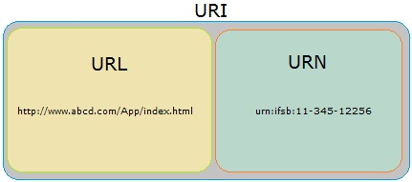

* Few Examples:-

URL: <ftp://ftp.is.co.za/rfc/rfc1808.txt>

URL: <http://www.ietf.org/rfc/rfc2396.txt>

URL: <ldap://[2001:db8::7]/c=GB?objectClass?one>

URL: <mailto:John.Doe@example.com>

URL: <news:comp.infosystems.www.servers.unix>

URL: <telnet://192.0.2.16:80/>

URN (not URL): urn:oasis:names:specification:docbook:dtd:xml:4.1.2

URN (not URL): urn:isbn:0-486-27557-4

# Web URL (Web Uniform Resource Locator's)

* Web URL, uniquely identifies a particular web resource inside a web application
* In other words, every web resource should have its unique address in the form of Web URL
* Max. number of characters allowed in Web URL is around 2000 characters (exact number depends on Browser. For ex, IE supports 2048 characters)
* Web URL Structure:

<Protocol://Domain:Port/Path?QueryString#FragmentID>

* Protocol in case of Web URL is always http or https
* Domain Name uniquely identifies a computer in a network in which web application is present. It can be Computer Name/DNS Name (preferred) or IP address
* Port number in Web URL uniquely identifies web server application
* Default port number for HTTP is 80 & HTTPS is 443
* In Tomcat Webserver, default port number for HTTP is changed from 80 to 8080 and default port number for HTTPS is changed from 443 to 8443
* Path is the full path of the web resource at web application side.
* It consists of, Web Application Name / Configured URL of a Resource
* "Web Application Name" uniquely identifies One web application inside webserver
* "Configured URL" uniquely identifies web resource inside that web application
* Query String is a name & value string pair which passes information in the form of name=value pair to web resources. In URL, It’s an optional information and if present, it starts with question mark followed by one or more name=value pair which are separated by an ampersand(&)
* A Fragment ID or Fragment Identifier, as the name implies, it refers to a particular fragment / a section within a web page
* Matrix Parameters are a set of “name=value”. They can be present anywhere in URL (generally used with **path**) & URL can consist of N number of Matrix parameters but they should be separate by a semi colon “;“
* The important difference between Query Parameters & Matrix Parameters is that,
* Matrix Parameters apply to a particular path element while
* Query Parameters apply to the request as a whole
* This comes into play when making a complex REST-style query to multiple levels of resources and sub-resources
* **Note:-**
* Apart from Domain Name rest of the components of Web URL are Optional
* Few Examples:-

<http://www.google.com/search?q=Praveen>

<https://www.google.co.in/search?q=ABC&sitesearch=www.youtube.com>

<http://www.example.com/res/categories;name=foo/objects;name=green/?page=1>

# eXtensible Mark-up Language (XML)

* XML is "Programing Language & Platform Independent Language" which helps to store and transport data
* Different Applications which are developed using different technologies can Transfer the Data among themselves with the help of XML
* As the name implies it's an extension of HTML & hence XML looks similar to HTML but it’s not a HTML
* XML has User-defind Tags. XML tags are also called as "elements"
* XML Elements are "Case Sensitive"
* XML is "Strictly Typed" Language hence,
* For every element data, “data-type” should be defined,
* every opening element should have corresponding closing element and
* also XML elements must be properly nested/closed

**Ex:**

<employee>

<name>Praveen</name>

</employee>

**Note:-**

In the above example first you should closed </name> & then </employee> but in HTML it’s not mandatory. For example, <B><U><I>My Text</U></I></B> works perfectly fine

* Below line is called as "XML prolog", which is optional. If it exists, it must be the First Line of XML

<?xml version="1.0" encoding="UTF-8" ?>

* The syntax of XML comment is similar to that of HTML

<!-- This is a comment -->

* File extension of XML is ".xml"
* MIME type (Content Type) of XML is "application/xml"

## XML Structure

* Like HTML, XML follows a Tree Structure
* An XML tree starts at a "root element" and branches from "root element" will have "child elements"
* XML Consists of "Only One" root element which is parent of all other elements
* "child elements" can have "sub elements / child elements"
* Structure

<root>

<child>

<subchild>.....</subchild>

</child>

</root>

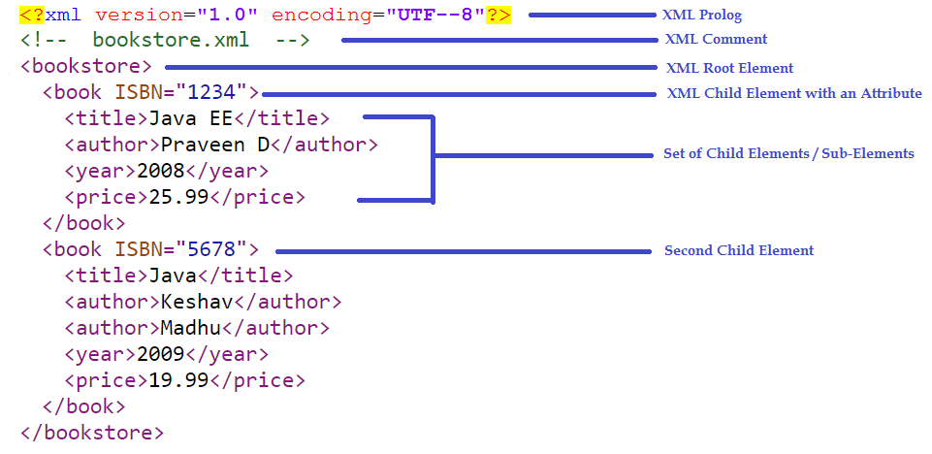

## Entity References

* Some characters have a special meaning in XML. If you place a character like "<" inside an XML element, it will generate an error because it represents the start of a new element

**Ex:** <message>salary<1000</message>

* To avoid this error, we can replace the "<" character with an "entity reference" as shown below

<message>salary **&lt;** 1000</message>

* There are 5 pre-defined entity references in XML:

&lt; < less than

&gt; > greater than

&amp; & ampersand

&apos; ' apostrophe

&quot; " quotation mark

## PCDATA: Parsed Character Data

* Text between start-element and end-element is called as PCDATA which will be examined by the parser

**Example:-**

<employee>Praveen</employee>

The string "Praveen" is considered as PCDATA

## CDATA: Character Data

* W.K.T special characters (such as "<", "&") must be referenced through pre-defined entities
* If XML data contain many special characters, it is cumbersome to replace all of them. Instead we can use "CDATA (character data) section"

* A CDATA section starts with the following sequence:

<![CDATA[

and ends with the next occurrence of the sequence:

]]>

All characters enclosed between these two sequences are interpreted as characters

* The XML parsers ignores all the mark-up within the CDATA section.

**Example: -**

<employee>Praveen</employee>

the start and end "employee" elements are interpreted as mark-up. However, if written like this:

<![CDATA[ <employee>Praveen</employee> ]]>

then the parsers interprets the same as if it had been written like this:

**&lt;**employee**&gt;**Praveen**&lt;**/employee**&gt;**

## XML Elements

* XML element is everything from (including) the element's start tag to (including) the element's end tag

* An element can contain:

1. data

2. Attributes

3. other elements OR

4. All of the above

* In the above example
* <title>, <author>, <year>, and <price> have text content
* <bookstore> and <book> have element contents
* <book> has an attribute (ISBN="------")
* An element with no content is said to be "empty". In XML, we can indicate an empty element like this

<element></element>

OR

<element />

* Empty elements can have attributes <book ISBN="5678" />
* If data present between elements consist of white spaces then they are considered in XML. However HTML truncates multiple white-spaces to one single white-space

## XML Elements Naming Rules

* they are case-sensitive
* they cannot contain spaces
* they must start with a letter or underscore
* they are cannot start with the letters like xml or XML or Xml etc.,
* they can contain letters, digits, hyphens, underscores, and periods
* Any name can be used, no words are reserved (except xml)

**Best Naming Practices**

* Avoid "." and ":"
* Create descriptive names, like

<person>, <firstname>, <lastname>

* Create short and simple names, like

<book_title> not like this: <the_title_of_the_book>

* Non-English letters are perfectly legal in XML but avoid them

## XML Attributes

* Like HTML, XML elements can also have attributes
* Attributes are designed to contain data related to a specific element
* XML Attributes Must be Quoted either single or double quotes can be used

**Ex:**

<person gender="female">

OR

<person gender='female'>

* If the attribute value itself contains double quotes then we can use single quotes

**Ex:**

<person name='Praveen "Bangalore" D'>

OR

<person name='Praveen **&quot;**Bangalore**&quot;** D'>

## XML Elements v/s Attributes

**Example 1:-**

<person gender="male">

<name>Praveen</name>

</person>

**Example 2:-**

<person>

<gender>male</gender>

<name>Praveen</name>

</person>

**Note:**

* In Example 1 gender is an attribute &
* In Example 2 gender is an element
* Both examples provide the same information
* There are no rules about when to use attributes or when to use elements in XML

**When to avoid XML Attributes?**

* Attributes cannot contain multiple values but Elements can
* Attributes cannot contain tree structures but Elements can
* Attributes are not easily expandable for future changes but Elements can

## XML Schema's

* W.K.T XML helps us to store & transfer the data
* When sending data from one application to an another, it is essential that both applications have the same "expectations / agreement" about the content/data
* for example, A date like "03-11-2004"
* in some countries, be interpreted as 3rd November and
* in other countries as 11th March

* With XML Schemas, the sender application can describe the data in a way that the receiver application will understand
* Schema is nothing but a "Structure". It is a formal description of structure of an XML.
* i.e., which elements are allowed,
* which elements must be present,
* which elements are optional,
* the sequence and relationship of the elements, etc.,
* For example,
* abc@gmail.com is a Valid Email ID. However
* abc#gmail is Invalid because there is "NO @ and ."
* hence email schema looks something like some-name@domain-name.com
* Schema "does not validate the data" instead "it validates the structure"
* There are two ways to define a Schema for XML

1. Document Type Definition (DTD)
2. XML Schema Definition (XSD)

### XML Document Type Definition (DTD)

* + A DTD defines the structure and the legal elements and attributes of an XML document
  + An application can use a DTD to verify that XML data is valid
  + There are 2 ways to declare the DTD
  1. An Internal DTD Declaration
  2. An External DTD Declaration
* An Internal DTD Declaration has the following syntax:

<!DOCTYPE root-element [

declarations

]>

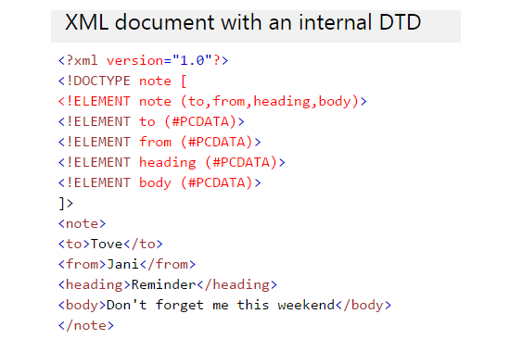

* A DTD can also be stored in an external file. An XML can reference an external DTD via the following syntax:

<!DOCTYPE root-element SYSTEM "DTD-filename">

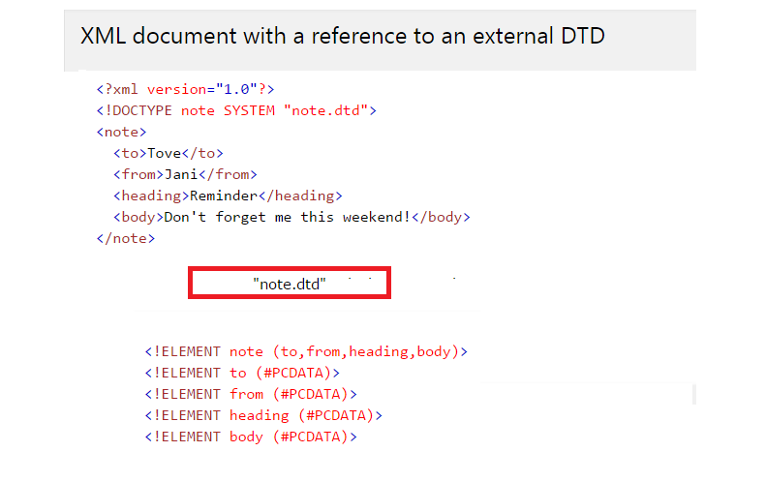

### XML Schema Definition (XSD)

* + XSD also describes the structure, legal elements and attributes for an XML
  + It defines,
* the elements and attributes that can appear in XML
* the number of and also the order of child elements
* data types for elements and attributes
* default and fixed values for elements & attributes
* One of the greatest strength of XML Schemas is the support for data types
* For Example, the following is an example of a date declaration in XSD:

<xs:element name="start-date" type="xs:date"/>

it defines the structure/format of the Date as "YYYY-MM-DD"

An element in XML might look like <start-date>2002-09-24</start-date>

* Another great strength about XML Schemas is that they are written in XML

* Hence XSD's are extensible so, we can
* Reuse Schema in other Schemas
* Create your own data types derived from the standard types
* Reference multiple schemas in the same document

**NOTE:**

* + Functionality wise both XSD & DTD similar in nature but XSD's are more sophisticated compared to DTD
  + In other words, DTD provides less control on XML structure whereas XSD provides more control
  + Hence XSD's preferred over DTD's
  + Without an XSD/DTD, an XML need only follow the rules for being well-formed
  + With an XSD/DTD, an XML must adhere to additional constraints placed upon the names and values of its elements and attributes in order to be considered valid

## Differences between DTD & XSD

|  |  |
| --- | --- |
| **DTD** | **XSD** |
| DTD’s are written in Mark-up Language | XSD’s are written in XML |
| DTD is not extensible i.e. We cannot inherit one DTD into an another | XSD is extensible. We can inherit one XSD into an another |
| DTD doesn't support data types (limited to string) | XSD supports data types for elements and attributes |
| DTD doesn't define order for child elements | XSD defines order for child elements |
| DTD's occurrence indicator is limited to 0, 1 and many; cannot support a specific number such as 8 | XSD can support a specific number |
| DTD doesn't support namespace | XSD supports namespace |
| We cannot inherit one DTD into an another | We can inherit one XSD into an another |
| DTD provides less control on XML structure | XSD provides more control on XML structure |

## Parsing XML Documents (XML Parsers)

* To process the data contained in XML documents, we need to write a application program (in any programming language such as Java/C/C++, etc)
  + - The program makes use of an XML parser to tokenize and retrieve the data from the XML documents
    - An XML parser is the software that sits between the application and the XML documents to shield the application developer from the details of the XML syntax.
    - The parser reads a raw XML document, ensures that is well-formed, and may validate the document against a DTD or XSD
    - There are two standard APIs for parsing XML documents:
  1. SAX (Simple API for XML)
  2. DOM (Document Object Model)
     + The JAXB provides a common interface for creating, parsing and manipulating XML documents using the standard SAX, DOM and XSLTs

# Java Architecture for XML Binding (JAXB)

* JAXB is part of the JDK (from 1.6 onwards) & "it is the most often used API to process XML "

* JAXB is a Java API helps us to convert Java Object to XML & vice-versa

* + - The Process of converting Java Object to XML is called as "Marshalling" OR "Serialization"
    - The Process of converting XML to Java Object is called as "Unmarshalling" OR "Deserialization"
    - "javax.xml.bind.*" is the package representation of JAXB
    - JAXB also helps us to generate XSD using Java Objects (with the help of "schemagen" commond)

* It helps us to Generate Java Objects using XSD (with the help of "xjc" commond)

* The JAX-RS API uses JAXB to convert the XML data from the request into a Java Object & vice-versa

## Commonly Used/Basic Annotations in JAXB

* W.K.T Java Annotations provide metadata on
* packages
* classes
* fields and
* methods
  + - Also each annotation type has its own set of "annotation elements"
    - JAXB can be used in two ways
* Creating our own Java Beans using JAXB Annotations
* Generating & Using Java Beans using XSD

### 1. @XmlRootElement

* + - A class that describes an XML element that is to be a top-level element, should be annotated with XmlRootElement
    - This annotation should be used with a Class Name
    - When a top level class is annotated with the @XmlRootElement annotation, then its value is represented as XML element in an XML
    - It has 2 Optional Annotation Elements

**1. name:-**

* It’s the name of the XML root element
* Default name is derived from the class name

**2. namespace:-**

* "namespace" name of the XML element
* Default is the empty namespace

### 2. @XmlElement

* + - This annotation helps to define an element in an XML
    - This Annotation should be used with Class Variables (preferred) / Getter Methods
    - By default JavaBeans Property Names are used as element names
    - The "name" element of this annotation defines name for an Element in XML

### 3. @XmlAttribute

* + - Specifies the attribute for XML element
    - This Annotation should be used with Class Variables (preferred) / Getter Methods
    - By default JavaBeans Property Names are used as Attribute names
    - The "name" element of this annotation defines name for an Element in XML

### 4. @XmlType(propOrder = { "field2", "field1",.. })

* + - This annotation should be used with a Class Name
    - This annotation with element "propOrder" allows to define the order in which the fields are written in an XML file

### 5. @XmlElementWrapper

* + - XmLElementWrapper generates a wrapper element around XML representation. Its used with collections (like array, Lst, Set, etc.,)
    - This is primarily intended to be used to produce a wrapper XML element around collections
    - By default JavaBeans Property Names are used as Element Wrapper name
    - The "name" element of this annotation defines name for an Element in XML

### 6. @XmlAccessorType

* This annotation defines the way class level annotation needs to be treated
* if @XmlAccessorType(XmlAccessType.FIELD) then

Class Variables should have JAXB Annotations

* if @XmlAccessorType(XmlAccessType.PROPERTY) then

Class Getter Methods should have JAXB Annotations

* if @XmlAccessorType(XmlAccessType.NONE) then

either Class Getter Methods/Class Variables (one of them) should have JAXB Annotations

* This annotation should be used with a Class Name along with @XmlRootElement
* If we have JAXB annotations for Class Getter Methods then this annotation can be avoided

## JAXB - Generating XSD using JAXB Annotated Class

**Command:**

schemagen -cp <Class_Files_Location> <Java_File_Location_Which_acts_as_Root_Element>

**Note:** <Class_Files_Location> should point the beginning of Package not inside the package

## JAXB - Generating Java Beans/POJO's using XSD

**Command:** xjc <XSD_File_Location>

**Note:**

* Generated Classes will be present inside the folder by name "generated"
* This folder will be present under the path where we run this command

Ex:- c:\jaxb>xjc d:\jaxb\schema1.xsd

then "generated" folder along the corresponding classes will be in "c:\jaxb" folder

## JAXB Marshalling [Converting Object into XML]

Steps:

--------

1. Create a Java Beans with JAXB annotations

or Using XSD generate the classes

2. Create the JAXBContext object

3. Create the Marshaller object

4. Invoke setProperty method on Marshaller object

by certain values (Optional)

5. Invoke the marshal method on Marshaller object

JAXB Unmarshalling [Converting XML into Object]

===================================================

Steps:

--------

1. Create a Java Beans with JAXB annotations

or Using XSD generate the classes

2. Create the JAXBContext object

3. Create the Unmarshaller object

4. Invoke the unmarshal method

5. Invoke getter methods of Java Bean to access

the data

javax.xml.bind.JAXBContext

===============================

> The JAXBContext class provides the client's entry

point to the JAXB API

> It is an Abstraction layer in JAXB which helps us

to perform basic operation of JAXB such as

marshal, unmarshal and validate

> Its an abstract class doesnot extend any other

JAXB related Class i.e.

public abstract class JAXBContext extends Object

> A client application normally obtains

new instances of this class using newInstance()

method

Syntax:

--------

public static JAXBContext

newInstance(Class... classesToBeBound)

throws JAXBException

> There should be ONLY ONE object of "JAXBContext" should exists

per application. In other words it should be accessed in "Singleton"

way. NOTE: "JAXBContext" is not Singleton in nature

javax.xml.bind.Marshaller

==============================

> Marshaller object is responsible for governing

the process of serializing Java content trees

back into XML data

> It provides the basic marshalling methods, to

convert Java Objects to XML

> It's an Interface & an instance of Marshaller is

obtained by invoking "createMarshaller()" method

on JAXBContext Object

Syntax

-------

Marshaller JAXBContext.createMarshaller()

throws JAXBException

javax.xml.bind.Unmarshaller

==============================

> Unmarshaller object is responsible for governing

the process of deserializing XML data into newly

created Java content trees, optionally validating

the XML data

> It provides lot of overloaded unmarshalling

methods, to convert XML to Java Objects

> It's an Interface & an instance of Unmarshaller is

obtained by invoking "createUnmarshaller()" method

on JAXBContext Object

Syntax

-------

Unmarshaller JAXBContext.createUnmarshaller()

throws JAXBException

Marshalling Example:-

=====================

JAXBContext jaxbContext

= JAXBContext.newInstance(

<Class_NM_Which_Represents_XML_Root_Element>);

Marshaller marshaller

= jaxbContext.createMarshaller();

marshaller.marshal(

<Object_Of a Class_Which_Represents_XML_Root_Element>,

System.out);

Unmarshalling Example:-

=====================

JAXBContext jaxbContext

= JAXBContext.newInstance(

<Class_NM_Which_Represents_XML_Root_Element>);

Unmarshaller unmarshaller

= jaxbContext.createUnmarshaller();

Object obj =

unmarshaller.unmarshal(new FileReader("fileNM.xml"));

JAXB Summary

=====================

I. Annotations Used:

----------------------

1. @XmlRootElement

2. @XmLElement

3. @XmlAttribute

4. @XmLElementWrapper

5. @XmlType

6. @XmlAccessorType

II. Java Classes Used:

----------------------

1. JAXBContext (Abstract Class)

2. Marshaller (Interface)

3. Unmarshaller (Interface)

4. JAXBException (Concreate Class)